

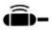
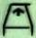
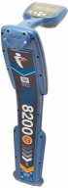
Quick Locating Guide for Radiodetection RD8200 and RD7200
Guidance Mode: The easiest; center the gap in the bar and follow the arrows.

Peak & Null: Compare the bar & arrows to determine accuracy; trust the peak signal the most.

Null Mode may have more errors.

“Max V”: on “High” can increase the signal without increasing errors.

Automatic depth: Rotate the compass to straight up and move above the utility.

Verifying depth: If the depth reading changes by the amount that you lift the locator, then it is accurate Ground Rod Placement: Select a rod location with no utilities between it and your utility.

Double ended connection: For challenging locates, connect both leads from the transmitter with an extension lead to the same utility.

Choosing Frequencies

Match the locator and transmitter frequencies. Use the lowest frequency that is strong enough. Lower frequencies are potentially more accurate. Higher frequencies are stronger. Check the mA display on the transmitter if direct connected to determine signal strength: 10mA minimum, 20 – 30 mA typical. Common frequency choices:
- Power cable with clamp: 33 Khz (8Khz better accuracy, higher for stronger signal)
- Metal water mains: 33 Khz minimum
- Locatable rodders: 33 Khz minimum
- Tracer wire: 512 hz if grounded on other end, 33 Khz if not grounded on other end

Cable fault locating:
1. Locate the cable then isolate both ends.
2. Connect black lead to ground stake and red lead to faulted conductor
3. Turn on transmitter, select transmitter frequency with A-frame picture, set output to max. 4. Connect A-frame. Turn on locator & it selects the A-frame frequency automatically.

5. Hold green spike in front of the locator and follow the arrows.
6. Check the whole cable. The numbers indicate the severity of the fault.

Sonde / Camera Locating:
- Choose the same frequency as the sonde.
- Use sonde mode.
- Hold the bottom of locator parallel to the pipe or conduit.
- Locate the major and minor sonde peaks

Passive Frequencies

Search then search again at 90 degrees to first pattern. Power: locates most utilities near a power cable with a load. Radio: finds most metal utilities.

PASSIV: Power and Radio combined (RD8200)

CPS: Locates most metal gas pipes, some water mains

RJM Equipment Sales, Inc 360-828-5732

brianmoss@rjmcompany.com

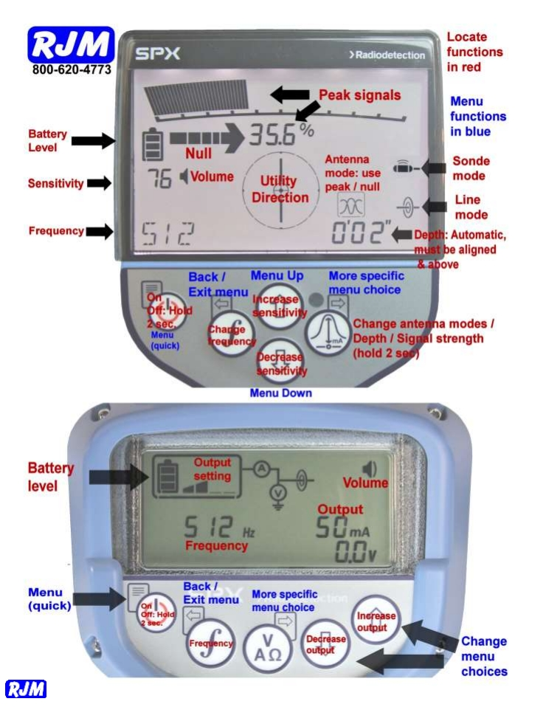
RJM Equipment Sales, Inc 360-828-5732

brianmoss@rjmcompany.com

